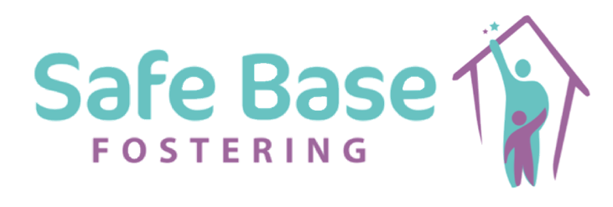

Statement in Respect of Modern slavery

Modern Slavery can occur in different forms; it can be seen as;

- Servitude
- Forced labour
- Human trafficking

All of the above involve the deprivation of a person’s liberty by another in order to exploit someone for personal or commercial gain. At Safe Base Fostering we are transparent in our business and apply high standards to our employment and contracting services. We have a zero tolerance to Modern Slavery and the exploitation of all vulnerable individuals.

Commitment to the principles of the Modern Slavery Act 2015

Safe Base Fostering Ltd is committed to the principles of the Modern Slavery Act 2015 [Section 54] and the abolition of modern slavery and human trafficking.

We are an equal opportunities employer and therefore work to ensure that our staff work in a non-discriminatory way. We expect our staff to respect and value the views of others.

We would expect that our staff would highlight any areas of discriminatory practice and that they are able to do so in confidence and with the support of the organisation.

Our recruitment and management processes are designed to ensure that all prospective employees are legally entitled to work in the UK and to safeguard employees from any abuse or coercion.

We would not enter into business with any organisation, in the UK or abroad, which knowingly supports or is found to be involved in slavery, servitude and forced or compulsory labour.

The Nature of our Business

Due to the nature of our business, we assess ourselves to have a low risk of modern slavery.

We are a small organisation who recruit and monitor from one central location. Therefore, we are able to closely monitor and supervise the business of the agency.

Our stakeholders and commissioners are well known to us and we interact with services from a restricted range of UK providers using existing Government frameworks and regulations.

Our policies which relate to the Modern Slavery Act 2015 are as follows:

The following policies are available to all staff, Foster Carers via our electronic database;

- Code of conduct
- Whistleblowing policy
- Bullying and harassment policy
- Diversity and inclusion policy
- Recruitment and selection policy

As a professional agency we will continue to embed the principles of the Modern Slavery Act 2015 by;

- Operating a policy of zero tolerance towards modern slavery and human trafficking.
- Ensuring we continue our robust recruitment practices
- Ensure staff know how to act if they suspect human trafficking

This statement has been approved by Safe Base three Business Managers, Owners and Directors; Hollie Barker, Alison Wells and Michelle Monteiro

